Process Plan Engine
EIS

** Document Version Information

Document Version Information
Version | Description of Changes | Date | Author
1 | Initial Draft | 9/19/05 | Betsey West

Document Scope
This document is specific to Iteration 2 of the MK Factory. It covers information relevant to that release only.

Introduction

Process Plan Engine: What does it do?
In the context of this project, a process plan is an xml document that describes all the information and procedures required to create a datamart. The process plan is the recipe that describes the product to be delivered in a completed state by the factory’s operation. It defines and describes the tools, information and steps required to create a datamart or a part of a datamart.

The process plan sets out the requirements for the creation of the delivery. Process Plans have no user interface component and very little (or no) human intervention in their creation.

Much of the information required for the process plan will vary depending on customer, product, and/or entitlement (contract), and maintaining the matrix of dependencies manually among these data could be quite cumbersome. It could also potentially be retrieved from a number of other systems inside IRI, such as the Siebel CAM system (for customer and contract information) or Oracle ERP for contract currency (did they pay?) information.

The system also needs to provide an English-like interface to business users to allow them to enter and maintain the required information as well as a common repository to organize and manage the information.

The Process Plan Engine will be implemented in the BRMS system from ILOG. It will be implemented as an embedded java engine.

There will be 5 rule sets, one for each section of the process plan. The rule sets would be used to bind values for certain variables that are required for the process plan. An example from the db Load section, in simple English, if-then format, would be

Process Plan Sections
As conceived by the OMS team, the process plan has 5 logical sections:
- Extraction
- Aggregation
- Db Load
- AS model
- Visualization

Extraction

The extraction section contains the information required to select the fact movement data from the Factory Data Warehouse (FDW). Included in the process plan are the names (references) to the files created in previous steps to guide Harvester in data extraction. For i2 only, the extraction section will also directly select one of the fact data files for MAT.

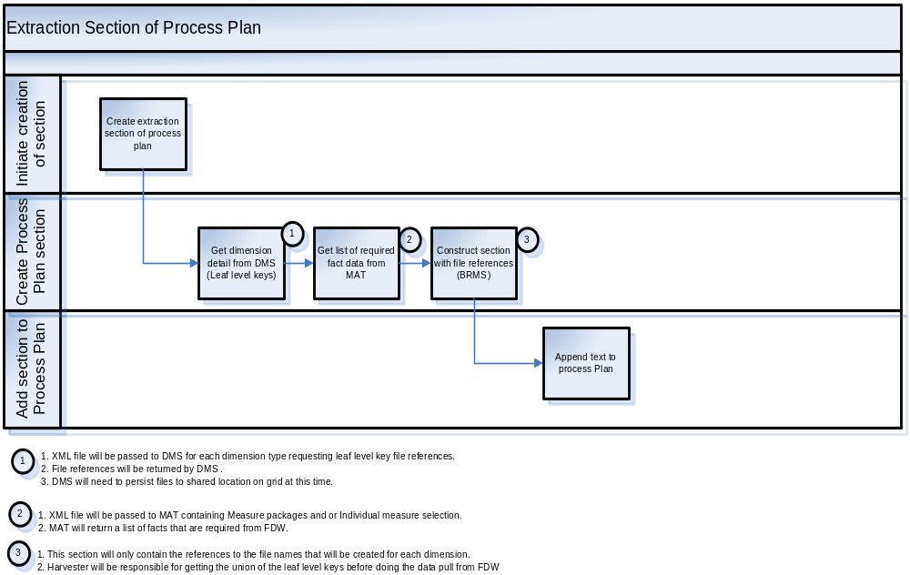

Aggregation

This section of the process plan contains details about how the aggregation of the data selected in the previous step is to occur. It contains references to the files created by the extraction services and also references to the fact movement data files created by the extraction section. The process plan is updated by the extraction step (in the factory) to include the references to the FDW data fles.

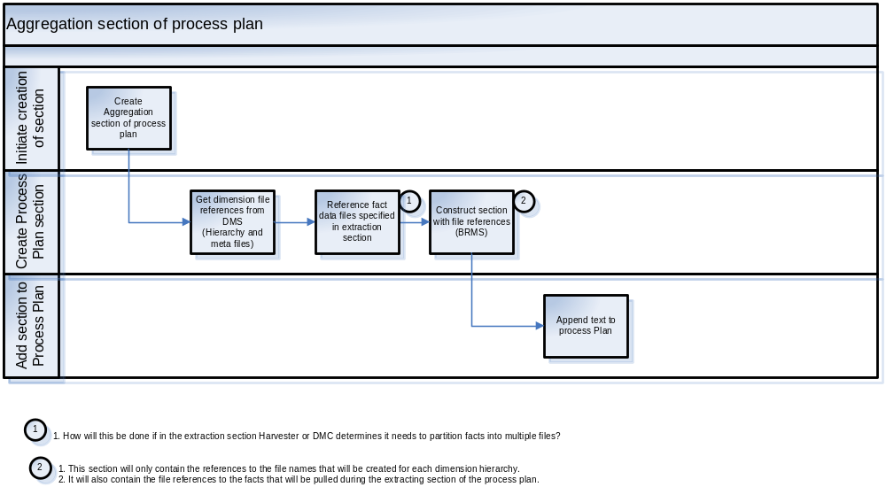

Database Load

The database loading section contains client specific information about how and where to stage the datamart created in the aggregation section. An example of a rule for this section, in simple if-them format might be:

“If clientid = 12674,
Then <DB_SERVER > = “marple”,
<DB_NAME> = “pepsi”,
<DB_LOGIN> = “pepsi”,
<DB_PASSWORD>= “fooldu”,
<DB_PORT> = 1521

For iteration 2, this information will be selected from the LOP database.

AS Model

This section would contain client specific information about how to build the AS Model. For a deliverable that was not an interactive datamart, this section would be absent.

An example of a rule for this section in simple if-then format might be:

If clientid = 12354
Then AS_HOST=platdev22
AS_PORT = 12345
AS_USER = superuser
AS_PASSWORD = pwd

Visualization

This section contains any required instructions to rebuild the “Companion” (meta model) for the client’s data so it can be accessed by RPM or PlusSuite.

The Pplan_Engine Service
The Trans_Process_Plan service calls the PPlan_Engine service to invoke the rules execution, passing in an xml object representing the process plan.

The PPlan_Engine service invokes BRMS to execute the resolution of the 5 parts of the process plan. Once the service has completed its actions, it returns the xml object to the Trans_Process_Plan Service.

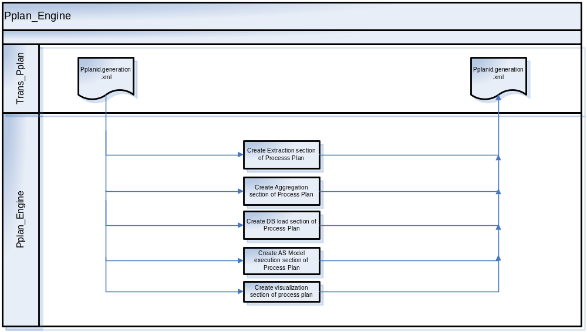

Figure 3. The PPlan_Engine flow.

Exception Handling
When an exception occurs an error message will be passed back to the calling service and the details of the error will be logged to Jets as per QC framework standards . (Log details to be determined)

